**MDF Rose Engine Lathe 2.0**

**with Stepper Motor Drive**

**Instructions for Building**

**Jigs, Fixtures, & Add-Ons**

**Version 1.3**

**14 July 2022**

This document is intended to help one familiar with the MDF rose engine to easily build the identified jigs, fixtures, and add-ons. You can purchase these from us at [www.ColvinTools.com](http://www.ColvinTools.com), or build them yourself.

As you get started with building these jigs, fixtures, or add-ons to the MDF rose engine lathe, please consider making the machine exactly according to the outlined instructions. There are lots of ways you can modify this, and, quite frankly, the MDF rose engine encourages experimentation. But it is best to attempt those modifications after understanding how it works. Some ideas which sound grand may not appear so after understanding how the machine works (we speak from experience).

If you have any questions on the terminology in this document, check out the “Ornamental Turning Book of Knowledge” ([www.OTBoK.info](https://www.otbok.info/)).

Throughout this document, I’ve tried to show the MDF in its native color of tan/brown. There are differences in the images I captured from the CAD drawing made, but those are not representative of the machine’s differences.

The added pieces are typically shown in different colors to ensure they stand out from the MDF rose engine lathe.

Unless otherwise noted, the MDF is ¾” thick.

If you have any questions, please contact us at [ColvinTools@Gmail.com](mailto:ColvinTools@Gmail.com).

Good luck and we hope you enjoy this machine as much as we.

Rich Colvin & Jack Zimmel

Permission is not granted to manufacture these for sale.

Table of Contents

Amplitude Adjuster 4

Bill of Materials 6

AA1 – MDF Spacer Block 8

AA2 – MDF AA Alignment Block 9

AA3 – Horizontal Bar 10

AA4 – Vertical Bar 10

105 – AA Lever Arm Axle 11

R1 – AA Rubber 12

Assembly 14

Using the AA 16

Amplitude Adjuster Components for Independent Amplitude Adjustment 18

Backstop 19

Clamp 20

Rosette Phaser / Multiplier 21

Bottom Piece 23

Top Piece 23

Side Pieces 24

# Amplitude Adjuster

The amplitude adjuster for the MDF Rose Engine Lathe 2.0 is shown installed to the right.

Also shown are some extra rubbers. Note that the RS1 has been flipped 180° to open up more space.

Details for building this follow the bill of materials.



This diagram shows the AA removed from the MDF Rose Engine Lathe 2.0.

## Bill of Materials

Parts required for building this are below.

| Item # | Item | Qty | Source | Source  Part Number | Comments |
| --- | --- | --- | --- | --- | --- |
|  | **MDF Parts** |  |  |  |  |
| AA1 | MDF Spacer Block | 1 |  |  |  |
| AA2 | MDF AA Alignment Block | 1 |  |  |  |
|  | **Machined Parts** |  |  |  |  |
| AA3 | Aluminum bar, ¼” x 1” | 1 |  |  | A piece 7 ¾” to 8” long is needed.  Used for the horizontal bar. |
| AA4 | Aluminum bar, ¼” x ¾” | 2 |  |  | Two pieces, 12 ½” to 13” long (each) are needed.  Used for the vertical bars. |
| R1 | Rubber, Pointed | 2 |  |  |  |
| R2 | Rubber, 2” Radius | 2 |  |  |  |
| R3 | Rubber, Flat | 2 |  |  |  |
|  | **Other Parts** |  |  |  |  |
| 101 | Carriage Bolts, ¼”-20, 4” long | 2 | McMaster-Carr | 93548A560 |  |
| 102 | Washer, ¼” | 8 | McMaster-Carr | 90107A029 |  |
| 103 | Lock Washer, ¼” | 1 | McMaster-Carr | 92146A029 |  |
| 104 | Nut, ¼”-20 | 5 | McMaster-Carr | 95505A601 |  |
| 105 | Bolt, ¼”-20 | 1 | McMaster-Carr | 90272A196 | Used as the axle for the vertical bars (AA4). Cut down per drawing on pg. 11). Need 1 ½” of unthreaded area. |
| 106 | Spacer, ¼” ID, ½” Long | 1 | McMaster-Carr | 92510A765 |  |
| 107 | Collar, ¼” ID | 1 | McMaster-Carr | 6432K12 |  |
| 108 | T-Track Bolt, ¼”-20, 2 ½” to 3” Long | 2 | McMaster-Carr |  |  |
| 109 | T-Track Nut, ¼”-20 | 2 | McMaster-Carr |  |  |
| 110 | Bolt, #8-32, 5/8” Long | 2 | McMaster-Carr | 90272A196 |  |
| 111 | Knurled Nut, #8-32 | 2 | McMaster-Carr | 92741A120 |  |

## AA1 – MDF Spacer Block

This spacer block is used to attach the AA to the headstock at the correct distance. You will need to drill two holes in H4L on the headstock to match the thru holes.



5 ¼”

2 7/8 ”

**Top View**



1 ½”

1 ½”

Holes drilled for ¼” bolts.

“G” bit recommended.

**Side View**

## AA2 – MDF AA Alignment Block

This is used to help keep the vertical bars aligned to the rosettes.



2 ”

3/8 ”

3/8 ”

3/8 ”

1/2 ”

3/4 ”

3/4 ”

5 3/4 ”

2 1/4 ”

1 3/8 ”

**Top View**



Holes drilled for ¼” bolts.

“G” bit recommended.

Center in slot for T-Track.

**Side View**

**NOTE:** There is also a 3D printable version in the 3D Printed Parts manual in the MDF Rose Engine Lathe 2.0 Library (<https://mdfre2.ColvinTools.com>).

## AA3 – Horizontal Bar

The horizontal bar is made from 1” x ¼” aluminum bar.



Hole drilled for ¼” bolt.

“G” bit recommended.

½”

½”

4”

7 ¾”

## AA4 – Vertical Bar

The vertical bars are made from ¾” x ¼” aluminum bar. There are two of these.



½”

8”

Hole drilled for ¼” bolt.

“G” bit recommended.

Hole drilled for #8-32 bolt.

#18 bit recommended.

12 ½” to 13”

## 105 – AA Lever Arm Axle

This is made from a partially threaded bolt. It can be cut with a hack saw, but be sure to smooth off the end, and chamfer it.

The one specified has sufficient unthreaded space.



~1 ½”

End is smoothed and chamfered after cutting.

## Square Description automatically generated with medium confidenceR1 – AA Rubber

Two are needed at any one time. More can be made. The basic shape to start with is like shown to the right, with measurements below.



½”

¼”

¾”



2 3/8”

2 3/8”

Through hole drilled for #8-32 bolt. #18 bit recommended.

1 3/16”

3/8”

Partial hole drilled for head of #8-32 bolt. Needs to be > 0.350”. 3/8” Forstner bit recommended. Drill this first. The point marks where to drill the through hole. Depth of the partial hole is 0.100” to 1/8”.

**Flat Rubber**

**Pointed Rubber**

### Various Rubber Shapes

Some examples of rubber shapes are below. Others can be made to accomplish the desired results.

|  |  |  |
| --- | --- | --- |
| **Pointed** | **Flat** | **Rounded**  **(2” Radius)** |

## Assembly

1. Drill the two holes needed in the headstock.
2. Attach the MDF Spacer Block (AA1) to the headstock using two carriage bolts with nuts and flat washers (#101, #102, & #104). The spacer block should be flush with the top of H4L.

**Looking from the back**

(H2 removed)



Nut

Flat Washer

MDF Spacer Block

Carriage Bolt

H4L

1. Attach the Axle (#105, cut as shown on pg. 11) to the Horizontal Bar (AA3) using two nuts (#104) and a lock washer (#103).
2. Add a flat washer (#102), one vertical arm (AA4), the spacer (#106), the 2nd vertical arm (AA4), and the collar (#107).



Lock Washer

Washer

Horizontal Bar

Vertical Bars

Nuts

Spacer

Collar

**Looking from the front**

## A picture containing text Description automatically generatedUsing the AA

1. Attach a rubber to each Vertical bar using an #8-32 bolt (#110) and a knurled nut (#111).
2. Attach the Horizontal bar to the MDF Spacer Block using two nuts and flat washers (#102 & #104). Ensure the vertical bars so that they are aligned with the front column (B3) on the MDF Rose Engine Lathe 2.0.
3. Add the MDF AA Alignment block (AA2) and hold it in place using two T-Track bolts (#108) and nuts (#109).



MDF AA Alignment Block

Front B3 Column

Vertical Bars

AA Rubbers

**Looking from the top**

MDF Alignment Block installed at the top of the front B3 column.

* If reducing amplification, install it at the top of B3.
* If increasing amplification, install it below the RS1 rubber support, but as high as possible so as not to interfere with the AA rubbers.

# Amplitude Adjuster Components for Independent Amplitude Adjustment

***These components can be used with the amplitude adjuster specified above. They are shown below and are installed on the MDF Rose Engine Lathe 2.0 in the picture to the left.

## Backstop

This is made from 3 pieces of ¾” MDF.



Holes drilled for ¼” bolt.

“G” bit recommended.

15”

12”

3”

1 ½”

5”

## Clamp

The clamp consists of two pieces of aluminum and two screws. Two clamps are needed.



> 1 ¼”

¾”

0.240”

0.240”



3/8”

1/8”

1/8”

Two Separate Pieces

The two screws are #8-32.

The thru holes on the L-shaped piece (the top one in the picture at the top right) are drilled #16 (0.177”). The screws simply feed thru these.

The thru holes on the flat piece (the bottom one in the picture at the top right) are drilled #28 or #29. These are tapped for a #8-32 screw.

# Rosette Phaser / Multiplier

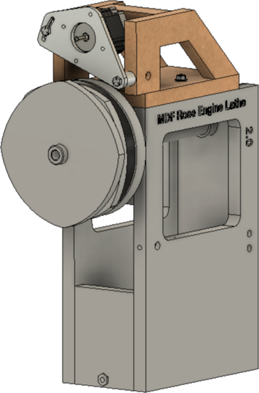This device is used to allow a second stepper motor to drive the rosette, separately from the stepper motor driving the spindle.

It is facilitated by the Multiple Stepper Motor Control System, version 3.0. The upper stepper motor is driven as the M3 axis.

This device uses a second copy of the same components as the spindle stepper motor drive:

* Motor bracket
* Motor bracket pacers (2)
* Motor bracket screws, washers, and nuts (2 sets)
* Stepper Motor Drive gear
* Spindle Drive gear
* Drive belt

Also needed is a Needle Roller Bearing (McMaster-Carr p/n 5909K36) to separate the two drive gears.

When using it with the **Amplitude Adjuster for Independent Amplitude Adjustment** outlined on 18, the arms will need to be spaced out an additional 0.85”:

* MDF Spacer Block will need to be 0.85” wider, and



2 7/8” + 0.85”

* MDF AA Alignment Block will need to be 0.85” further away from the vertical T-Tracks to which it attaches.



1/2” +

0.85”

This is to accommodate the second drive gear, and the needle roller bearing, and aligning the rubbers with the new position for the rosettes.

## Bottom Piece

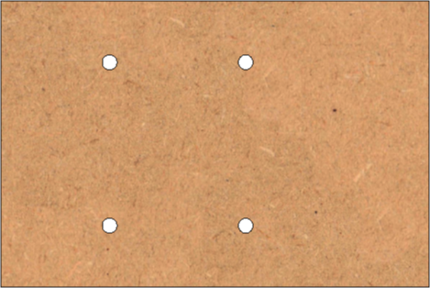

1 1/8”

1 1/8”

5 1/4”

7 7/8”

2 1/2”

2”

This is made from ¾” MDF. One is needed.

The 4 holes are ¼” in diameter. These accommodate the screws which hold this device to the top of the headstock (via the T-Tracks).

## Top Piece

This is made from ¾” MDF. One is needed.

3 3/4”

1 1/2”



## Side Pieces



Drill ¼” diameter,

2” deep

8 3/4”

2”

2”

7/8”

4 5/8”

1 1/2”

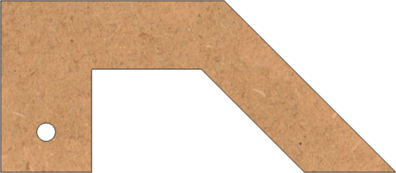

1”

Drill 13/32” diameter,

Through

This is made from ¾” MDF. Two are needed.

On the front piece, drill holes as shown.

Do not drill into the back one yet piece yet; drill those after aligning the stepper motor bracket.

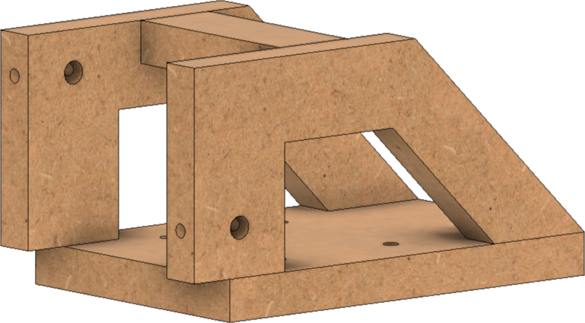Once assembled, the MDF pieces will look like this.